S_ALR_87099931 -

Functionality
In this transaction you can compare the selected cost estimates against a material master price that you select.

Scenario
You want to compare the cost estimate calculated in the particular costing run with the current standard price of materials.

Requirements
Costing run was created and the step ‘Costing’ in the costing run has been executed.

Menu Path | Accounting → Controlling → Product Cost Controlling → Product Cost Planning → Information System → Summarized Analysis → Analyze Costing Run → S_ALR_87099931 - Price vs Cost Estimate
Transaction Code | S_ALR_87099931

1. Double click on S_ALR_87099931 - Price vs Cost Estimate

Analyze/Compare Material Cost Estimates

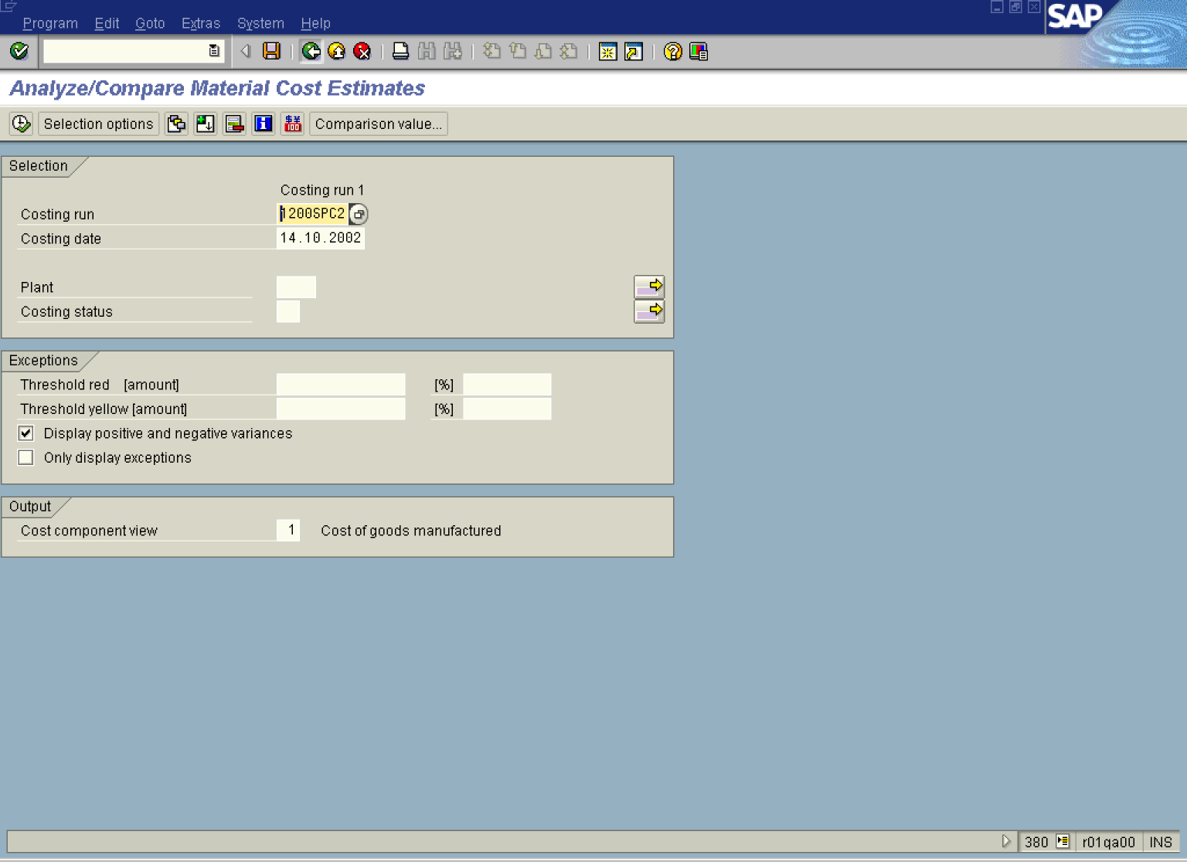

2. Press [F4] or click the Search button in the Costing run field.

Name of costing run (1)

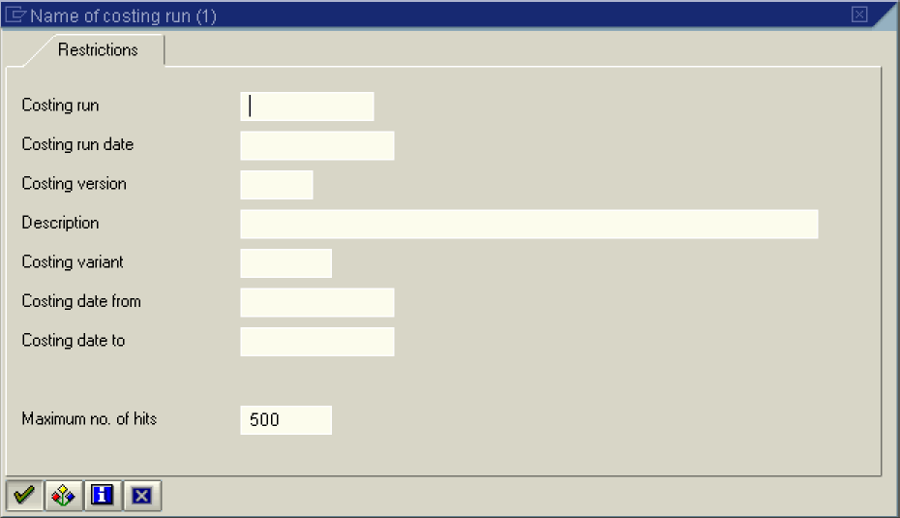

3. Click the Continue button.

Name of costing run (1) 9 Entries found

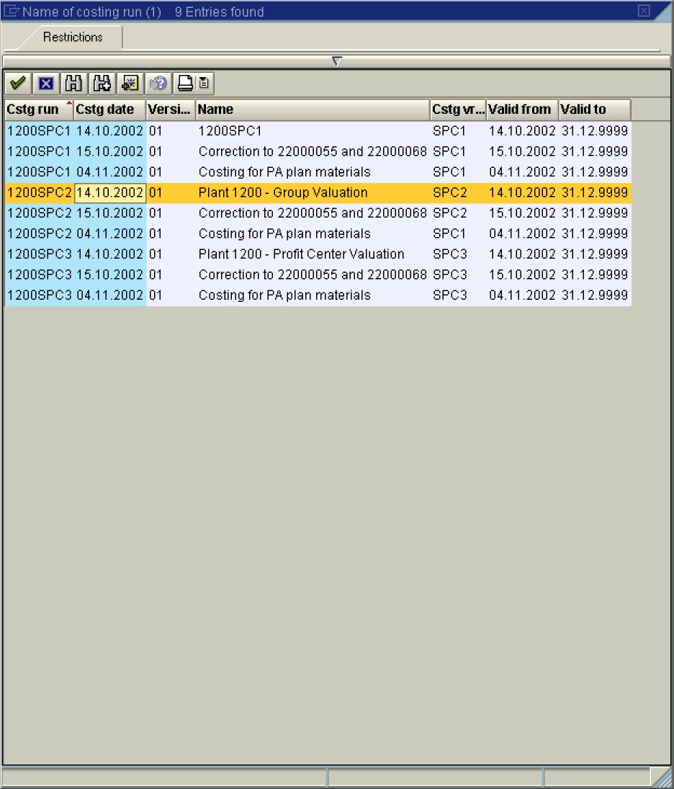

4. Double click on the 1200SPC2 - 14.10.2002 in list box.

Analyze/Compare Material Cost Estimates

5. Click the Execute button.

Analyze/Compare Material Cost Estimates

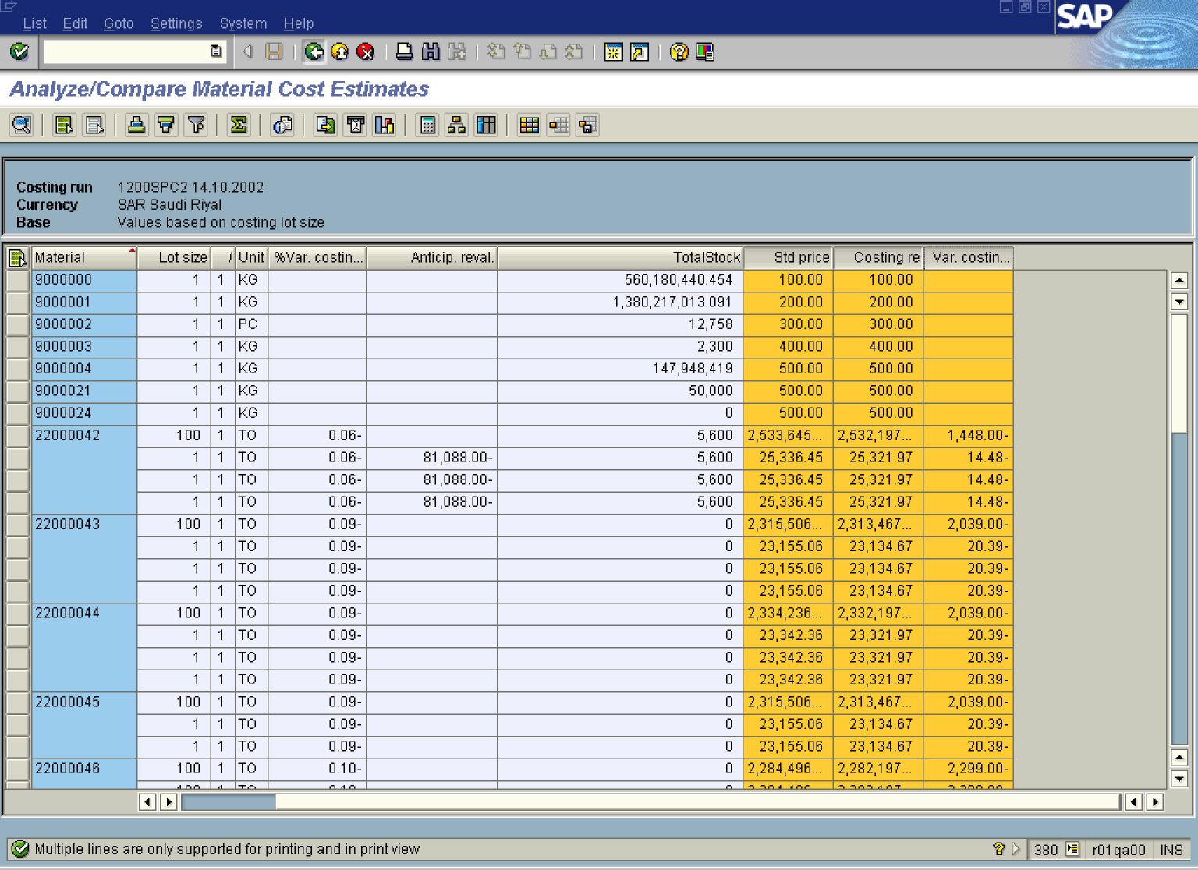

6. Click the Back button.

Exit list



7. Click the Yes button.

Analyze/Compare Material Cost Estimates

8. Click the Back button to go back to SAP Easy Access screen.

